# CS 255 System Design Document Template

## UML Diagrams

### UML Use Case Diagram

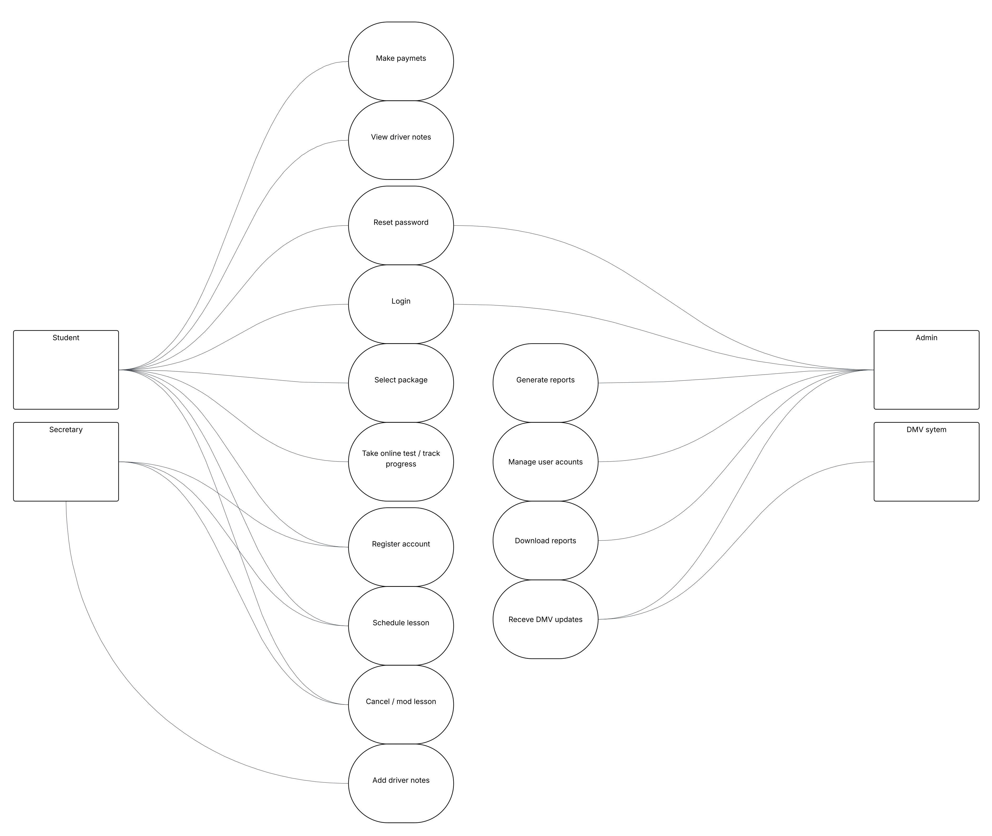

### UML Activity Diagrams

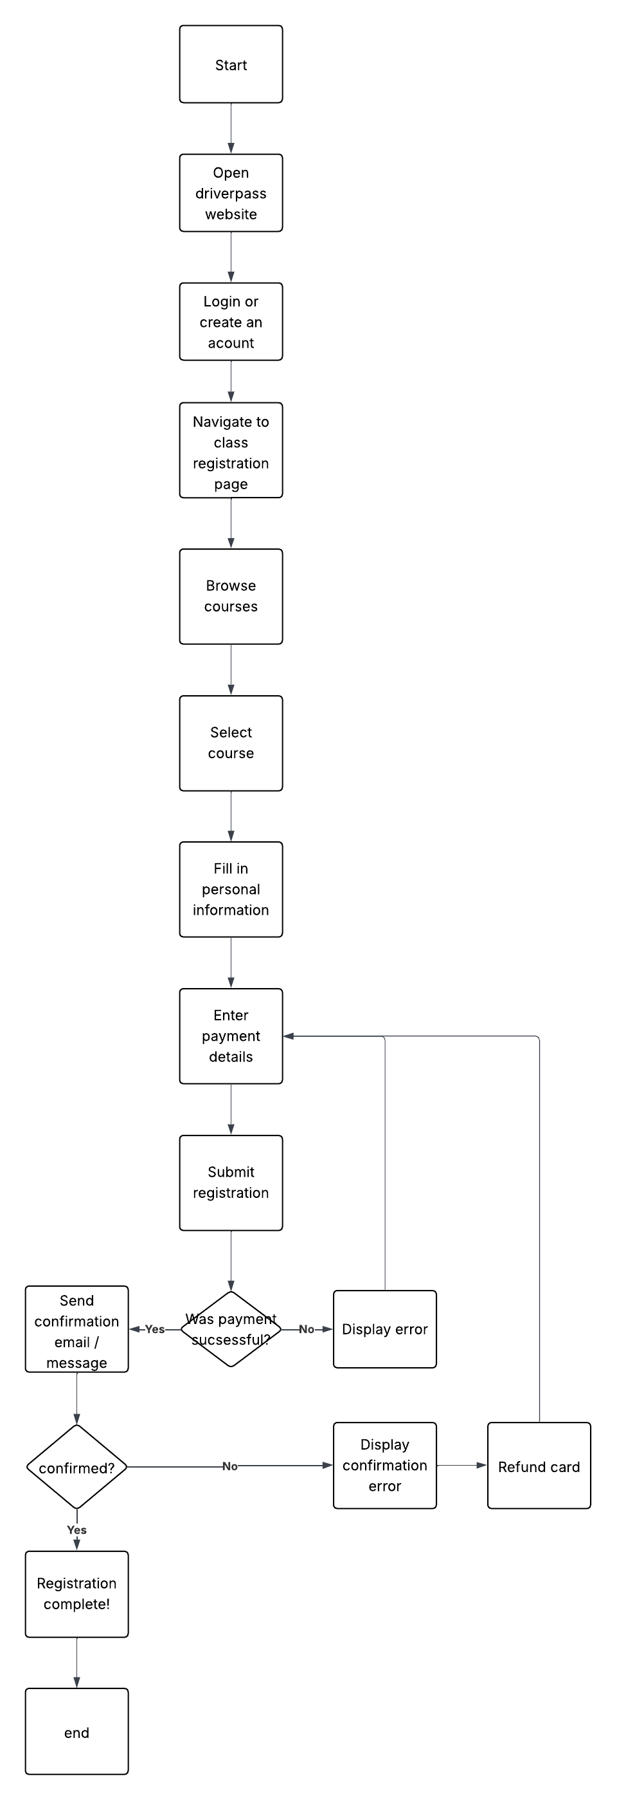

### UML Sequence Diagram

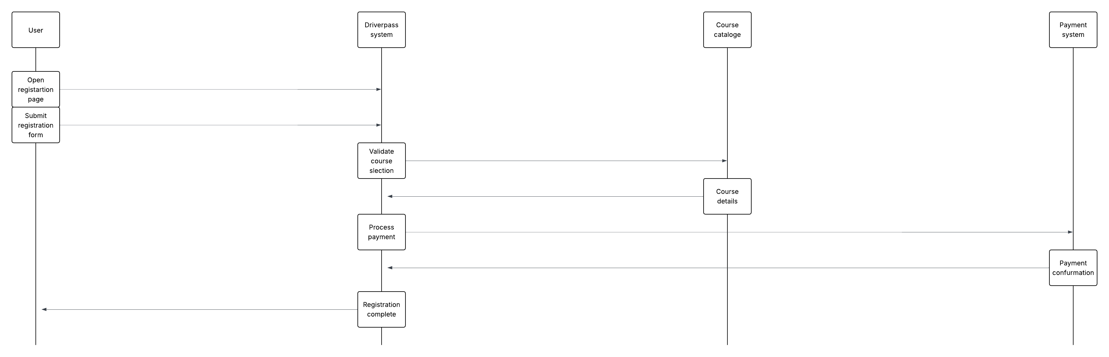

### UML Class Diagram

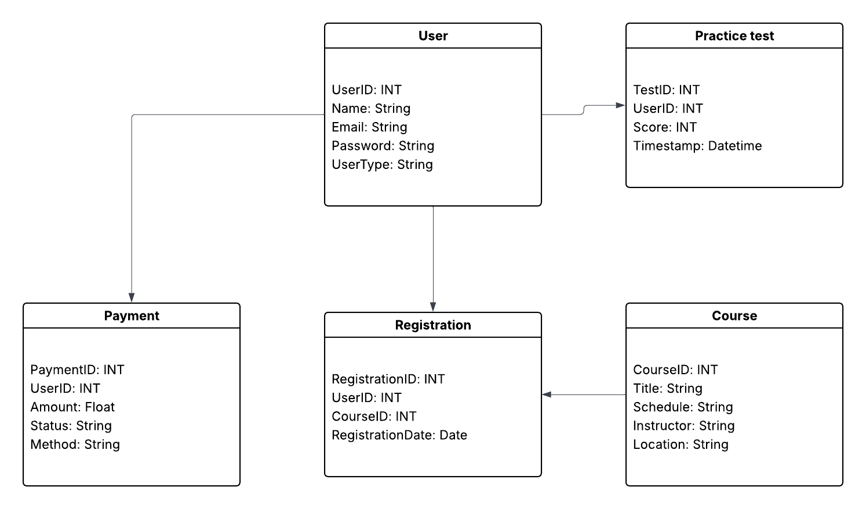

## Technical Requirements

Based on the system design, the following are the required technical specifications:

Hardware:

* Cloud-hosted server with 16+ GB RAM and SSD storage
* Client devices: Compatible with desktops, tablets, and smartphones

Software:

* Frontend: HTML5, CSS, JavaScript
* Backend: Node.js with Express or Python Django
* Database: MySQL or PostgreSQL

Tools:

* Lucidchart (for modeling)
* Visual Studio Code or similar IDE
* GitHub for version control

Infrastructure:

* Secure cloud platform (e.g., AWS or Azure)
* SSL encryption and role-based access control
* Load balancer to handle peak demand